Fruit Ninja User Guide

Player will choose either begin game using play or add new player if it is his first time to play the game as shown in

figure 1.

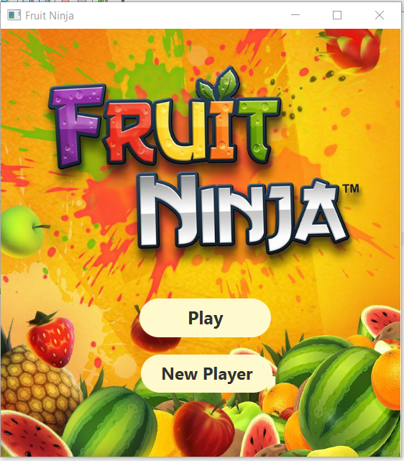

**FIG 1: Game First Screen**

If *New Player* button is pressed, then register screen will appear and he should insert his name, username and add a password as shown in figure 2.

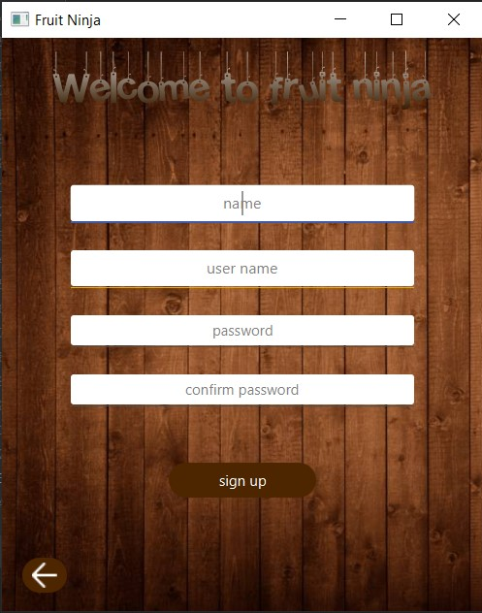

**FIG 2 : New Player Screen**

If *play* button is pressed, sign in screen will appear so user should insert his username and his password as shown in figure 3.

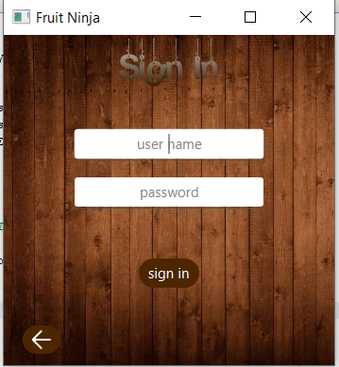

**FIG 3: Sign in screen**

If his username and password is validated then he will choose between one of the game mode as shown in

figure 4.

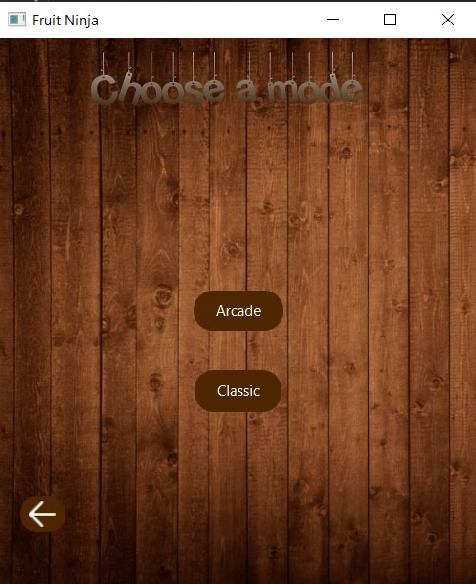

**FIG 4 : Game Mode**

If *Arcade* button is pressed, Arcade screen will appear, In arcade player lose score if he slice the black bomb, game also has a certain time which is sixty second, Arcade Game as in figure 5.

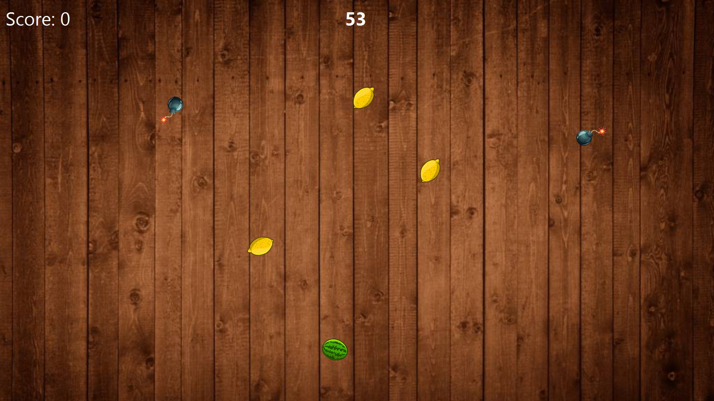

**FIG 5. Arcade Game Mode**

If  *Classic* button is pressed, classic screen will appear, in classic mode player has three lives and player lose one if he didn’t slice the fruit or he slice the black bomb and if user cut the black red bomb he will lose the game, classic game as in figure 6.

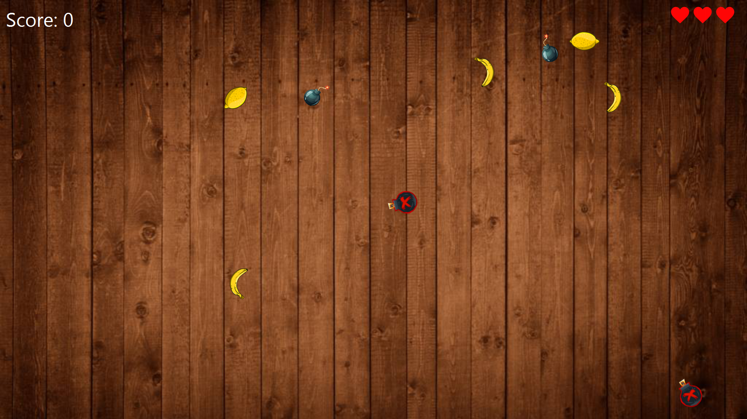

**FIG 6. Classic Game Mode**